**ASR 4545 - Labeling Task Triggering Mechanism in Sch WMS**

Detail requirements;

* 1. Product list setup for labeling requirement: the criteria for system to validate should be:
     1. Affected country;
     2. Affected product codes
  2. System validation upon create wave:

Validate:

Should there’s same shipment with different labeling requirement within the DN/Shipment: system will perform

As when the shipment contains different labeling requirements, system will prompt an alert to outbound admin.

Outbound admin will have option to choose to proceed or revert.

* 1. Pick List – to display labeling instruction message at the header and line item level.

Example;

**From:** Yen Lin Tan [<mailto:yen_lin_tan@bd.com>]   
**Sent:** Wednesday, 16 July, 2014 10:01 AM  
**To:** Chan, Pei-Fong; Jack Fong; Jaya Ganesh  
**Cc:** Tan, Ching Siow; Min Yuan Seow; Teck Seng Tan; Zhi Ai, Huang  
**Subject:** RE: Labelling Task Triggering Mechanism in Schenker WMS

Hello Pei Fong

Yes, but I would not want it to ‘block’ and becomes and error as it would make the system very rigid.

What if we do not sufficient load to fill up the entire container load for example and we won’t be able to combine such orders to optimize the container load.

I would like to have it setup as a ‘warning’ to the CS who is planning the container load and if he required he / she can overwrite accordingly.

So in the ideal case that u have shared (if there is sufficient container load)  and if the system catch it, we will ask planner to delete the 2nd item and redrop and we will reprocess as below.

|  |  |  |  |  |  |  |
| --- | --- | --- | --- | --- | --- | --- |
| Shipment# (New) | Shipment # (current) | Delivery (Original) | Delivery (NEW) | SKU | Item | Require labeling ? |
| 1111 | 1111 | 123 | 123 | A | 10 | Yes |
| ~~1111~~  3333 | 1111 | 123 | Cancel and redrop as 125 | B | 20 | No |
| ~~2222~~    1111 | 1111 | 124 | 124 | C | 10 | Yes |

On the other hand, if after validating and checking through and there is no more order we can pull in to be shipped together, than the shipment will move with all products.

|  |  |  |  |  |  |  |
| --- | --- | --- | --- | --- | --- | --- |
| Shipment# (New) | Shipment # (current) | Delivery (Original) | Delivery (NEW) | SKU | Item | Require labeling ? |
| 1111 | 1111 | 123 | 123 | A | 10 | Yes |
| 1111 | 1111 | 123 | 123 | B | 20 | No |
| 1111 | 1111 | 124 | 124 | C | 10 | Yes |

**Yen-Lin TAN**  
Regional Logistics Manager, Asia Pacific

**BD**  
30 Tuas Avenue 2,   
Singapore 639461,   
Office: +65 6690 8611 Mobile: +65 9734 9818  
Email: [Yen_Lin_Tan@bd.com](mailto:Yen_Lin_Tan@bd.com) Website: [www.BD.com](http://www.bd.com/)

Date : 5 Aug 2014   
**WMS Changes Requirement:**

1. **Maintain SKU Labeling**

* By Country
* By SKU - Set SKU = “ALL” if refer by Country

Eg Data:

|  |  |
| --- | --- |
| Country | SKU |
| AU | ALL |
| IN | 301746 |
| IN | 301747 |
| IN | 302100 |

1. **Create Wave – label validation**

System to prompt alert message if found different labeling requirement per shipment number or DNs

Date Completed: 11 Aug 2014

Application: Kodigo WMS- Changes:

* + 1. **[Setup] -> SKU Labeling**

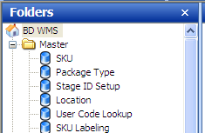

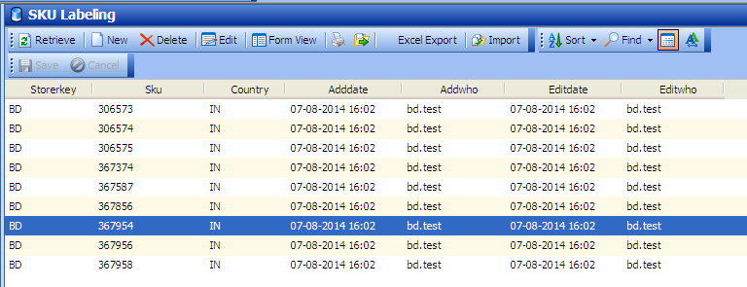

**[Import]** function – this to import new SKU labeling setup. System will ignore the existing record.

File import format in excel file:

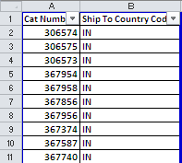

** System will insert new record, and skip the existing record if found in the list.

For deletion of records, please use the [Delete] button on the toolbar menu.

* + 1. **[Outbound ] -> Picking Management**

Validate and prompt when shipments contains part with different label requirements w

TEST1 Shipment# 104201111 – with different Label requirement

Total lines# 8, total SKU count required labels = 7

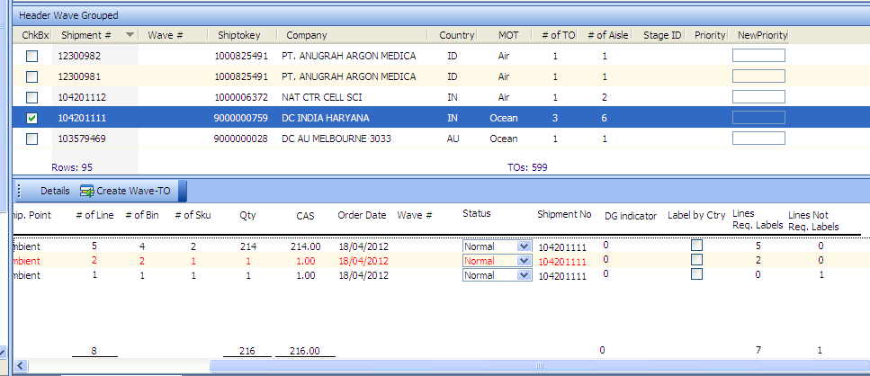

System prompt alert message:

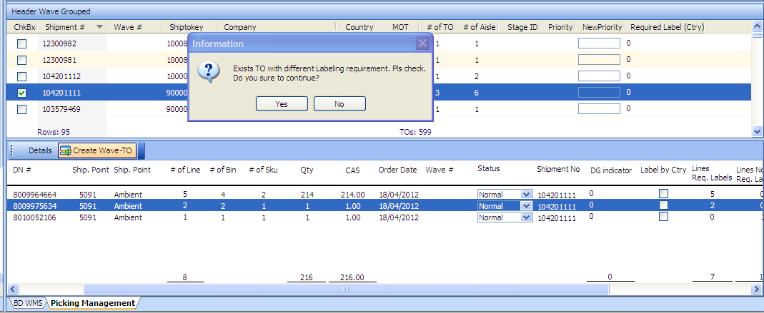

If click [NO] – system do not create wave – pick list not generated.

If click [YES] – system proceed to create wave – pick list will be generated

Wavekey = **0000000131**

* + 1. Pick List – added Label Instruction on the pick list header and each item require label.

Sample:

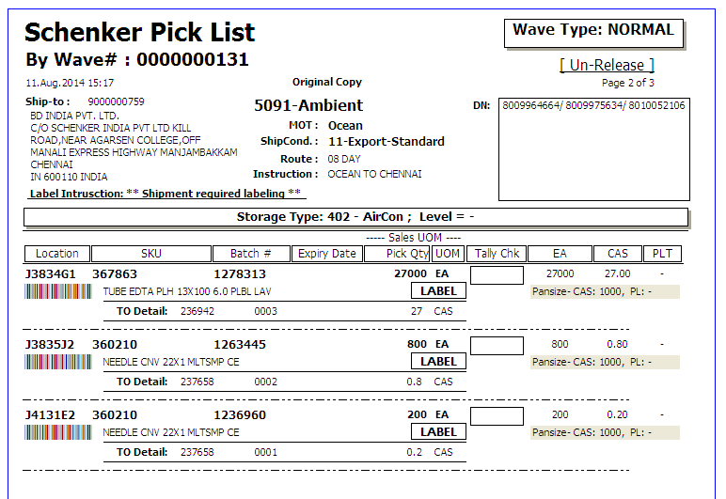

***IT Development Notes:***

Pick_management

Header Create Wave

Dw_entry.buttonclicked()

Detail Create Wave

Event : Parent.ke_detailCreatwave

Pick List – SP: [SCH_BD_REPORT_PICKLIST]